

IC2 Integra Web – Embedded mode
WebView using C# and WebView2 (Edge – Chromium)

Contents
1. Purpose of the document 3
2. Using IC2 Integra Web as embedded WebView with C# and WebView2 4
2.1. Technical recommendations 4
2.1 Project preparation 4
2.2 Navigating to the IC2 Integra URL with form POST data 5
2.2.1 Preparing payload (sample) 5
2.2.2 Navigating to IC2 Integra 6
2.3 Bi-directional communication with IC2 Integra Web 7
2.3.1. Receiving events from IC2 Integra Web 7
2.3.2 Sending events to IC2 Integra Web 9
2.4 Issuing Success event 10
2.5 Error event 11
3 Conclusion 12

Purpose of the document
The purpose of the document is to provide the best practices and tips with code samples to developers working on integration of Global Blue’s IC2 Integra Web integrated issuing solution in embedded WebView mode using C# and a new Webview2 component which is based on Edge (Chromium).
WebView2 with Chromium engine will provide maximum compatibility with IC2 Integra Web and will allow access to the latest features (e.g. Anyline or Virtual Keyboard) which doesn’t support previous Webview component based on Internet Explorer.

Using IC2 Integra Web as embedded WebView with C# and WebView2

Technical recommendations
For creating a WebView, the below recommendations should be followed and sample code should be considered by developers using C#
For a WebView there are two main components which can be used for integration on Windows and which are both based on Chromium engine: a) already mentioned Webview2 using Edge component and b) CEF (Chromium Embedded Framework) especially its c# implementation called cefsharp for easier usage in .net c# projects.
This document covers usage of Webview2 because opposite to cefsharp it has some advantages and therefore it is best practice.
Advantages of using Webview2:
- Engine updates automatically with the updates of Edge browser…
- …thus no need to update and distribute manually with every new chrome version
- No need to bundle with app… smaller distribution package
- Easier integration with .NET apps (WinForms/WPF)
Disadvantages:
- Requires Microsoft Edge to be installed (but it’s standard on Win11)

Project preparation
First of all, to be able to use the webview2 we need to use package manager and add the component dependency into the project.
Open the NuGet package manager and add Microsoft.Web.Webview2 into project:
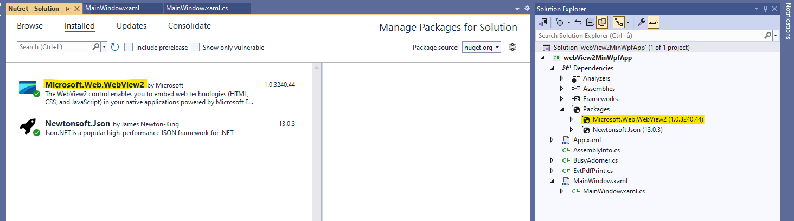
Recommended webview initialization is on screenshot below:
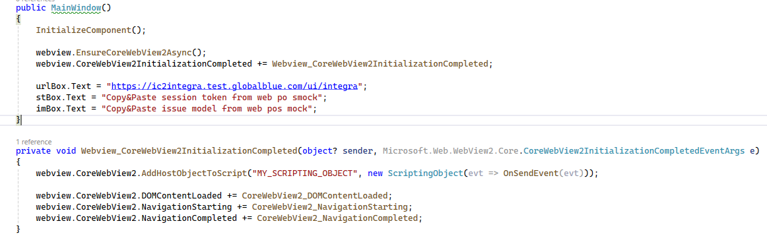
It’s good practice to wait till the webview instance is properly initialized which is done by calling EnsureCoreWebView2Async method and waiting for the initialization done event to be completed CoreWebView2InitializationCompleted. If successful, then it’s sure that CoreWebView2 inner object of webview is not null and can be safely used for another initializations.

Navigating to the IC2 Integra URL with form POST data
When opening IC2 Integra web, data and parameters has to be passed. This is done by POST call with payload. For simplicity with various types of integrations the POST payload needs to send data in form-urlencoded form (as for web forms) and that’s why Content-Type header has to be set to application/x-www-form-urlencoded and payload has to be formatted such way.

Preparing payload (sample)
As said in previous chapter payload has to be properly formatted. www-form-urlencoded formatting requires the payload to be a string of key-value pairs concatenated with ampersand symbol (&, same way as of url parameters: key1=value1&key2=value2&….keyN=valueN
Very important thing is to set the shellmode through this parameter to true. This will be essential mainly for setting up the bi-directional communication (later in this document). By setting the shellmode to true the POS is letting IC2 Integra know that it should set and prepare shell and mainly to support to hooks to be able to communicate: JSB_SendEvent and JSB_OnEvent.
Sample code how to prepare payload (notice the shellmode=true):
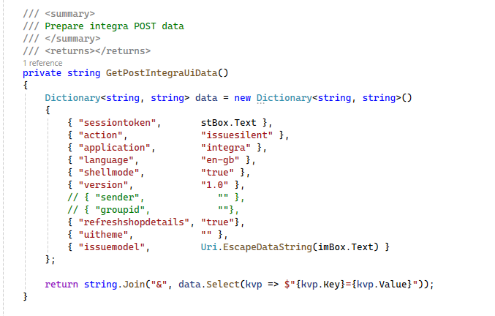
Note: stBox.Text and imBox.Text are the WPF UI TextBox fields to fill in the GB SessionToken and IssueModel.

Navigating to IC2 Integra
Navigating to IC2 Integra means to open the webview with specified endpoint (for integra usually ending with /ui/integra), sending the requested payload as array of bytes and specifying the content type.
Variables (from the screenshot below) are urlBox.Text containing the integra web endpoint and webview which is Webview2 component instance.
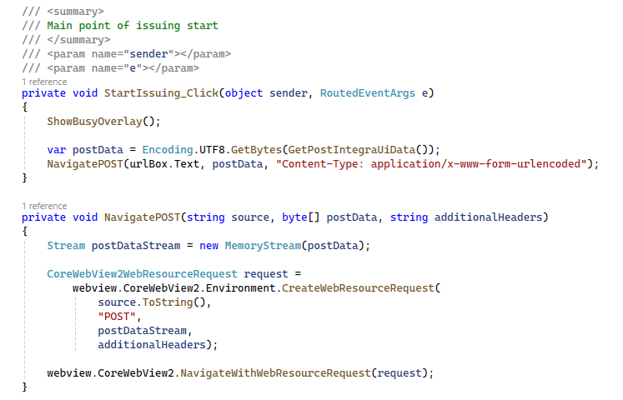

Bi-directional communication with IC2 Integra Web
In order to be able to receive events from the IC2 Integra Web (e.g. docId or TFF pdf data, errors,..) and send events back to IC2 Integra Web (e.g. setup shell capabilities like available scanners etc.) it’s vital to setup bi-directional communication. In fact if there’re no requirements or implementation specifics only the one-way communication back to POS is necessary and sending events back to IC2 Integra might be optional.

2.3.1. Receiving events from IC2 Integra Web
To be able to receive any event from IC2 Integra Web there has to be created a class and its instance will serve as a bridge between the C# app and the javascript Integra app running in webview.
On the picture below is a sample class of the bridge (or host object).
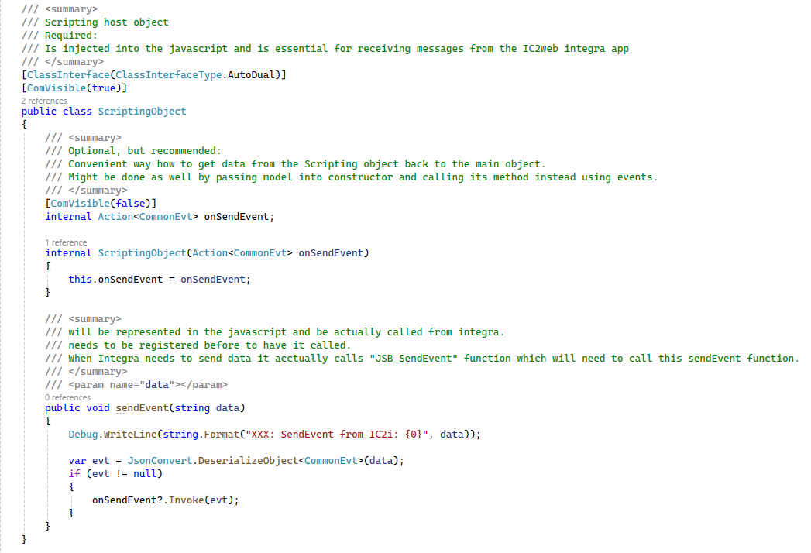
Implementation at the picture adds more code than necessary. The most important is to mark the class with attribute ComVisible(true). Second is the definition of the function sendEvent which will be then called from javascript shell of the IC2 Integra Web. Through optional onSendEvent member can be flow returned back to main object instead of implementing all logic here in the bridge (host object). This can be done also e.g. with model instance passed to the class through constructor and calling model’s method in the sendEvent function.
Once the host object class is ready, it needs to be registered with the webview. It’s done by calling the AddHostObjectToScript method:
First parameter of the method is the name (our custom name) of the object in the javascript dom model. Second is the instance of the bridge (object host) class. In the constructor parameter is passed function which is a event handler for events received from IC2 Integra Web.
Example of a basic structure of the OnSendEvent handler is on the screenshot below:
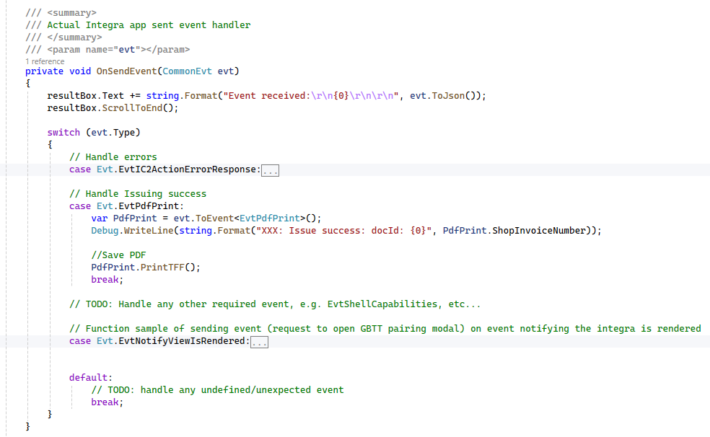
Last but very important thing to do to make the communication from IC2 Integra Web to POS functional is to define the shell hook function to call the bridge’s sendEvent method:
On The picture above (and from the code below) can be see the javascript function which will be defined in the javascript object model of the IC2 Integra Web and it will be called when event needs to be sent to POS.
function JSB_SendEvent(data) {
window.chrome.webview.hostObjects.sync.MY_SCRIPTING_OBJECT.sendEvent(JSON.stringify(data));
}
NOTE: MY_SCRIPTING_OBJECT name which has been used on AddHostObjectToScript call.
NOTE2: sendEvent function name in the javascript object model which is already a function name from our bridge (object host).

2.3.2 Sending events to IC2 Integra Web
Sending events back to IC2 Integra Web is much easier and it requires just to execute script on the javascript engine of the app. The method which needs to be executed has been already mentioned in previous chapter (2.2.1) and it is called JSB_OnEvent. By calling this method the C# app says what event and what data. Then IC2 Integra Web knows what to do based on the event.
On the picture below is an implementation of the sending method SendEventToIntegraApp and the example of usage. In this case it will send event to open GBTT Pairing modal popup once the IC2 Integra Web is fully rendered and the POS is notified by EvtNotifyViewIsRendered event.
Some events as in this case are simple and doesn’t require any data. Some like EvtShellCapabilitiesData will require also Data member which will contain json object defining all shell can do.
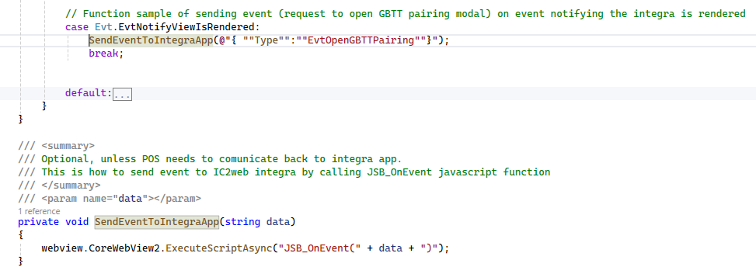

Issuing Success event
In case the TFS from was successfully issued, the POS system will receive a JSON event named EvtPdfPrint. The structure of the event data will be as below:
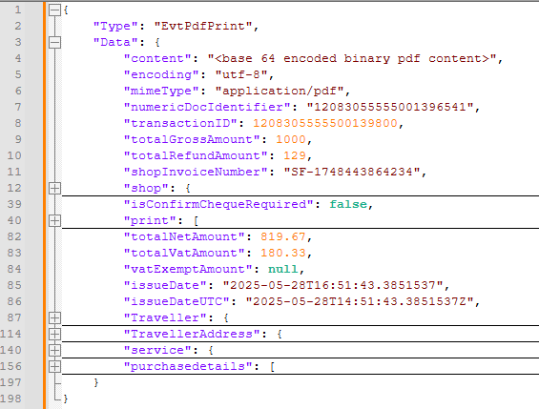
{
encoding: string,
numericDocIdentifier: string,
transactionID: string.
mimeType: string,
content: string //base64 encoded
Traveller //traveller details object
TravellerAddress //traveller address object
TotalGrossAmount,
totalRefundAmount,
shopInvoiceNumber¨
…
}

Received TFF pdf data in field content can be then read and saved. Sample code how to save:
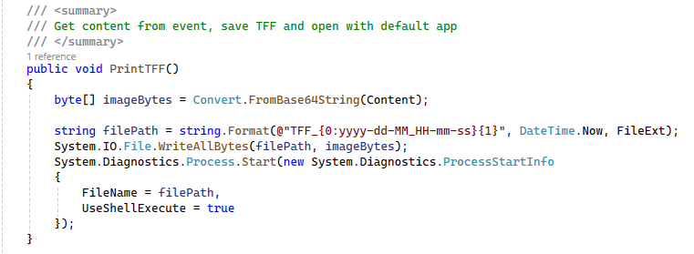

2.5 Error event
Another very important event is error event. Whenever an error will occur during IC2 Integra Web life cycle (which includes also services behind), it will respond with error event EvtIC2ActionErrorResponse. Handling of this event is very recommended. It will include the information what was going wrong (e.g. wrong VAT during loading, wrong data, etc.):
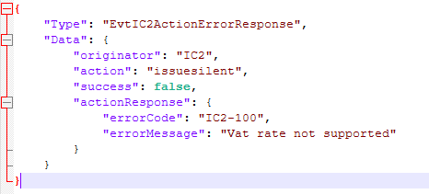

Conclusion
This document includes basic code samples but complete information essential for successful integration of the IC2 Integra Web into other systems using Microsoft WebView2 component based on Edge (Chromium).
All screenshots have been done from fully functional minimal viable implementation of IC2 Integra Web integration (aka POS simulator) which is part of the documentation and can be downloaded from the same page.

